CHARGES AND COULOMB’S LAW
1.What is the work done in moving a test charge ’q’ through a distance of 1cm along the equatorial axis of an electric dipole?
2. Why is Millikan’s Oil Drop experiment, the charge measured was always found to be of some discrete value and not any arbitrary value?
3. What is meant by electrostatic shielding?
4. Why an electric dipole placed in a uniform electric field does not undergoes acceleration?
5. Why electric field lines
(i) Can never intersect one another?
(ii) Cannot form closed loops?
6.Show that a point where the electric field intensity is zero, electric potential need not be zero.
7. What is the electric flux through the surface S in Vacuum?
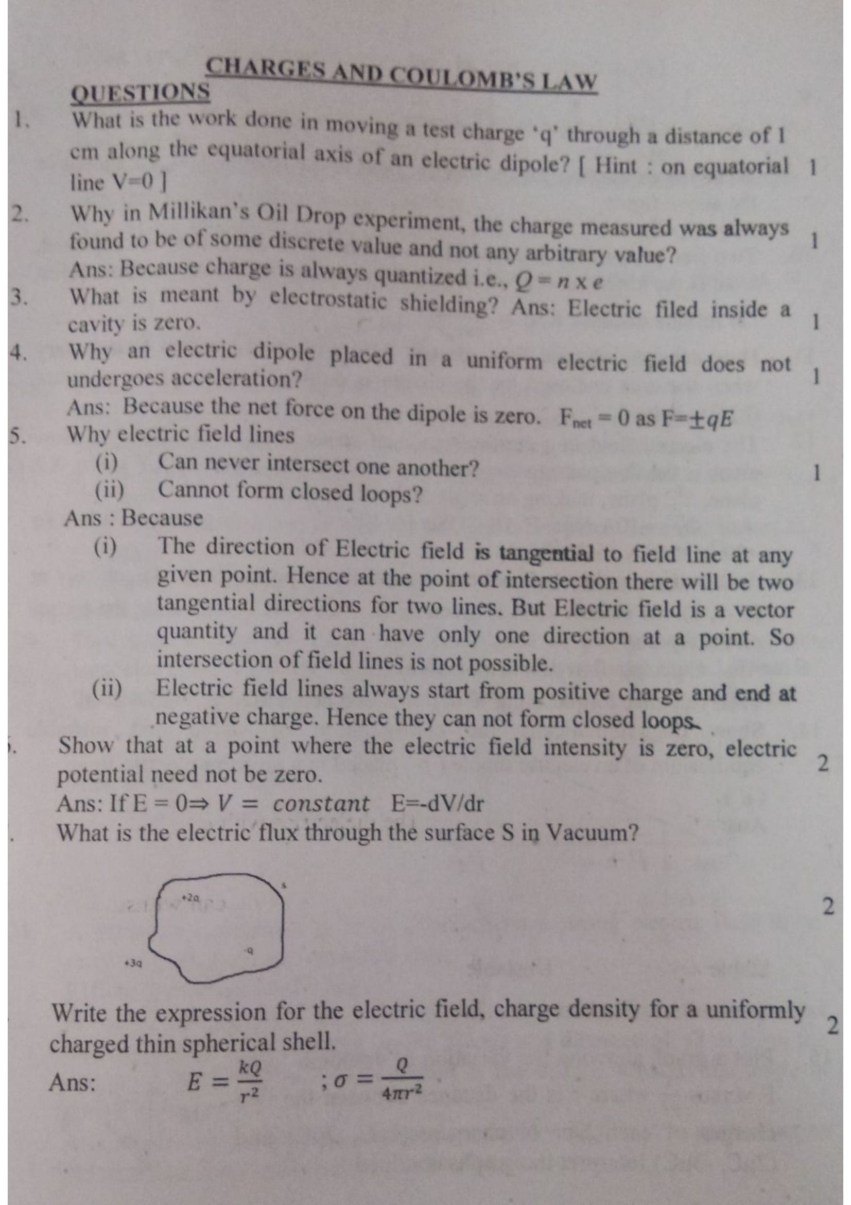
8. Write the expression for the electric field, charge density for a uniformly charged thin spherical shell.
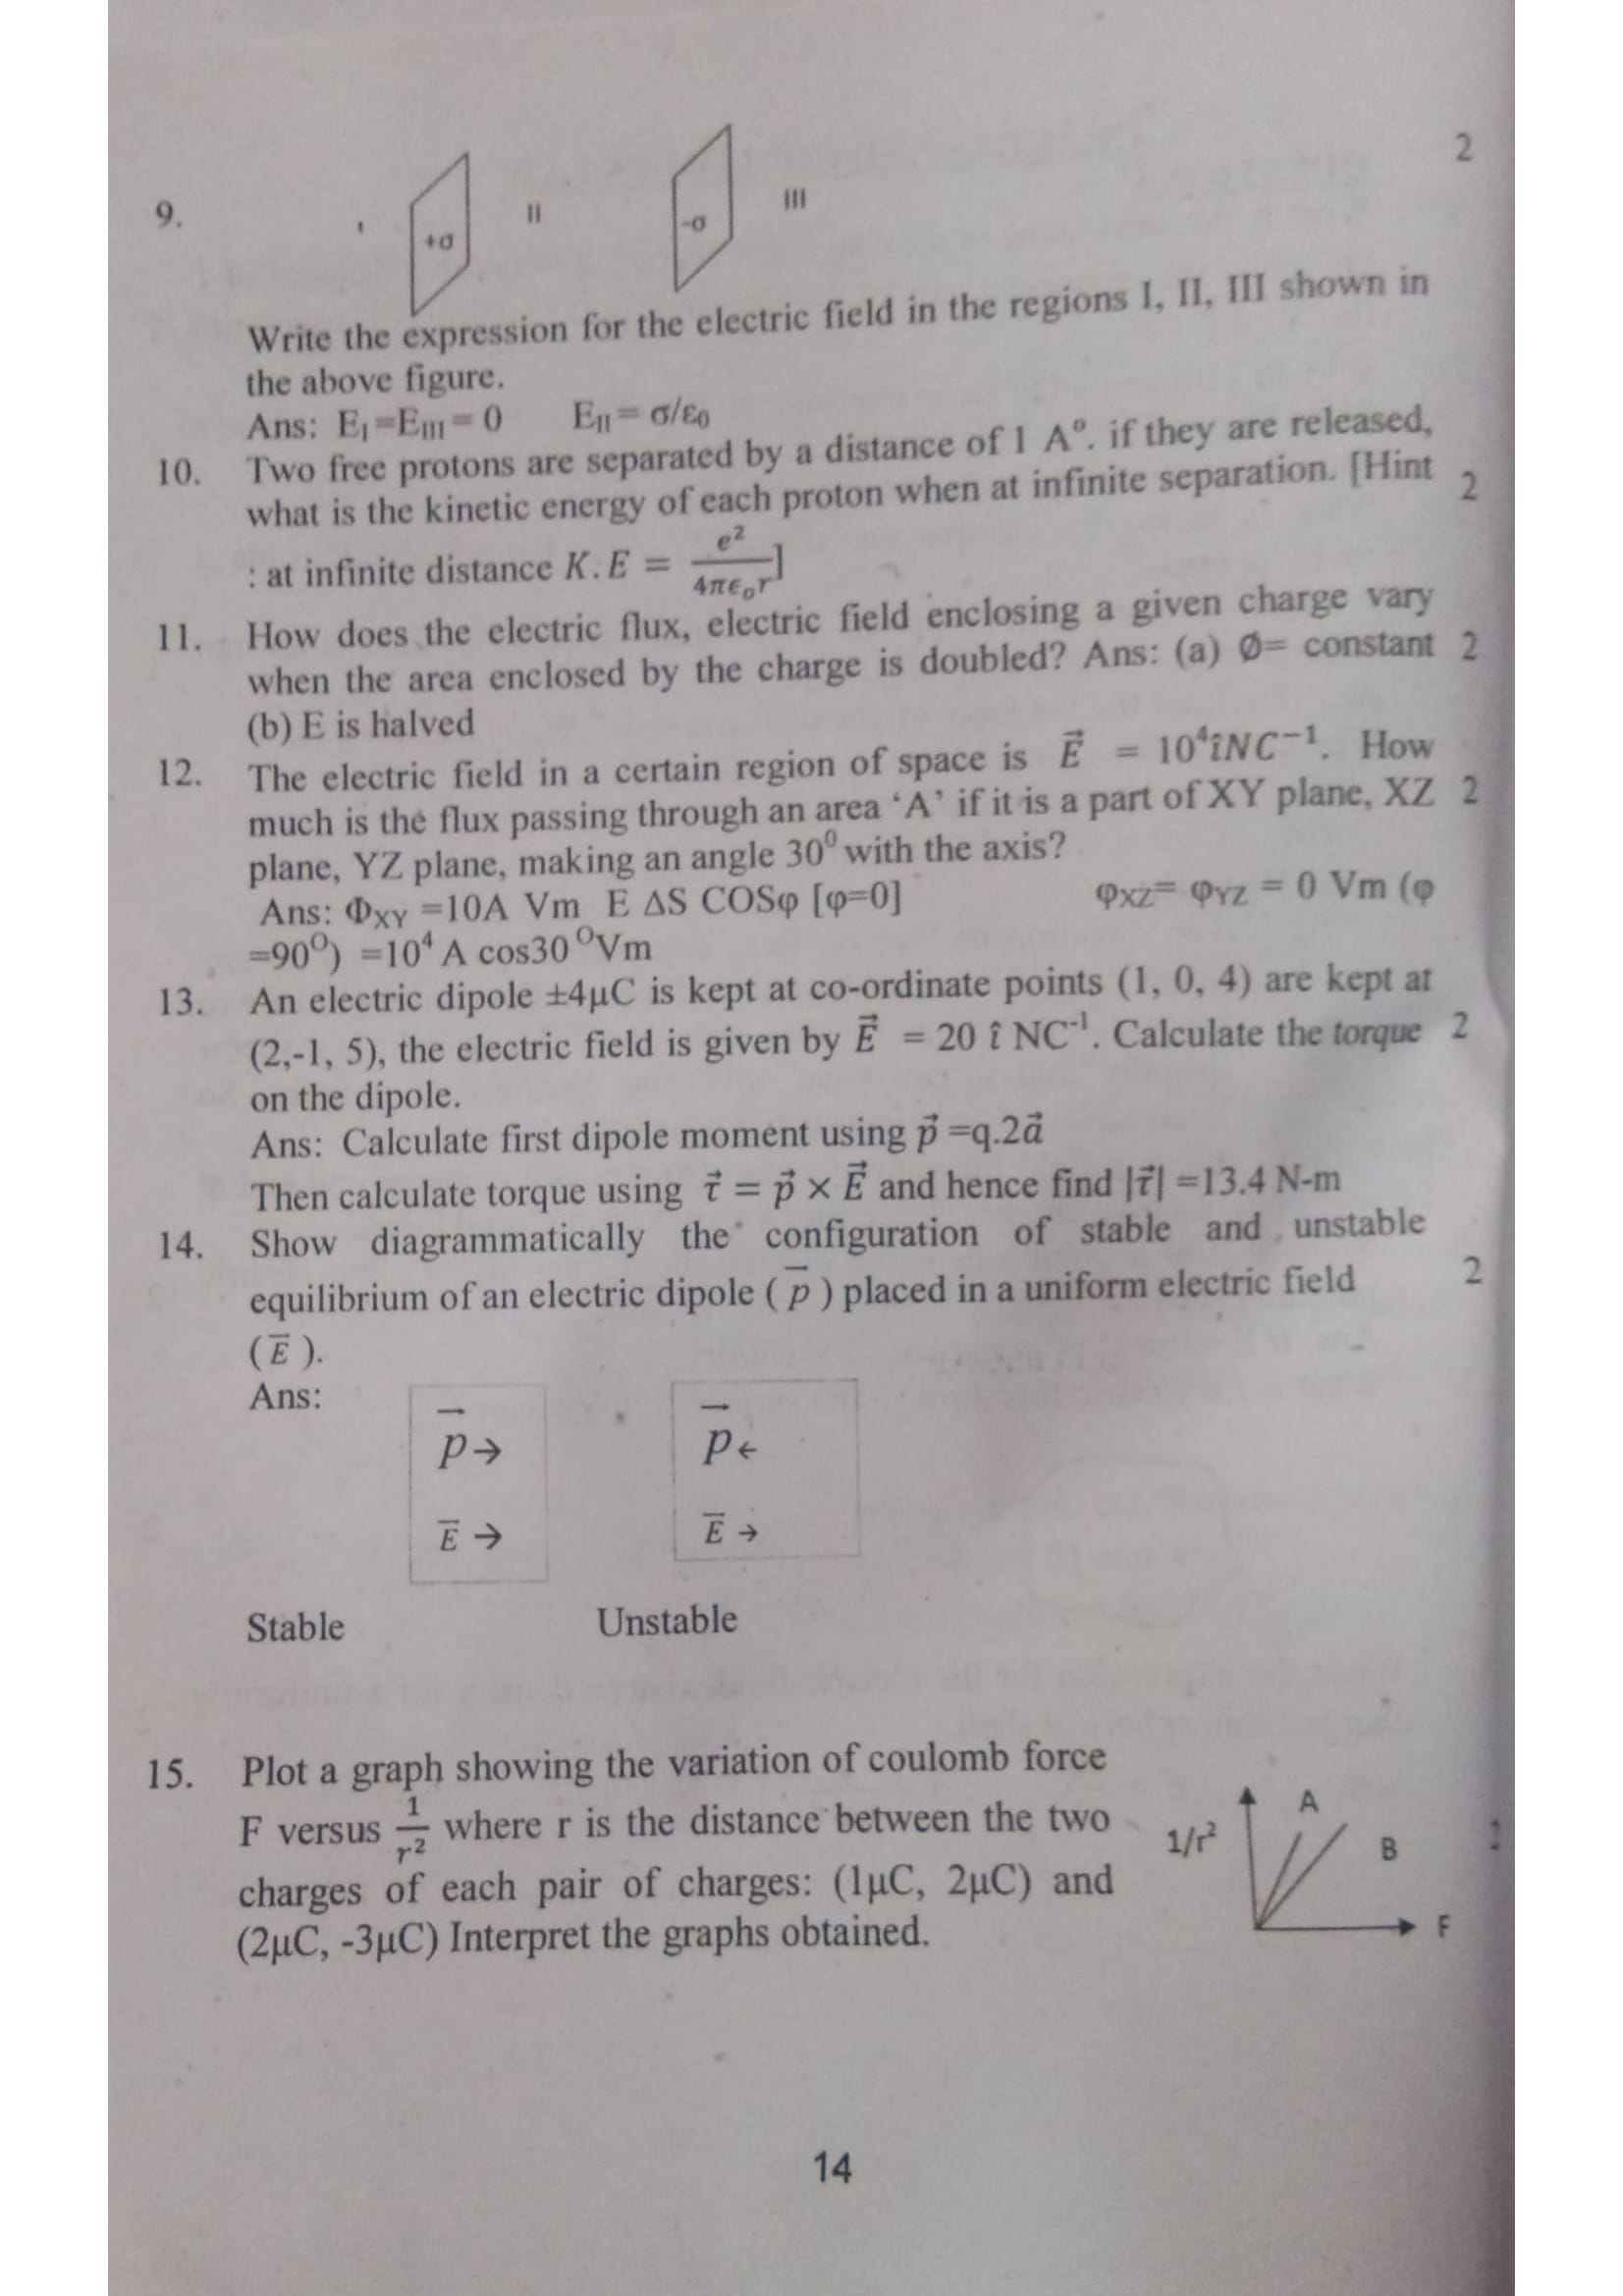
9.

Write the expression for the electric field in the regions I, II, III shown in the above figure.
10. Two free protons are separated by a distance of 1 A^{0,} if they are released what is the kinetic energy of each of each proton when at infinite separation.
11.How does the electric flux, electric field enclosing a given charge vary when the area enclosed by the charge is doubled?
12.The electric field in a certain region of space is =10⁴iNC⁻¹ How much is the flux passing through an area ‘A’ if its is a part of XY plane, XZ plane, YZ plane, making an angle of 30⁰ with the axis?
13. An electric dipole ±4µC is kept at co-ordinate points (1,0,4) are kept at (2,-1,5) the electric field is given E→=20 iNC⁻¹ . Calculate the torque on the dipole.

14. Show diagrammatically the configuration of stable and unstable equilibrium of an electric dipole () placed in a uniform electric field ( ).
15. Plot a graph showing the variation of coulomb force F versus 1/r² where r is the distance between the two charges (1µC, 2µC) and (2µC, -3µC) Interpret the graphs obtained.
16. A thin straight infinitely ling conducting wire having charge density λ is enclosed by a cylindrical surface of radius r and length I, its axis coinciding with the length of the wire. Find the expression for electric flux through the surface of the cylinder.
17. Calculate the force between two alpha particles kept at a distance of 0.02mm in air
18. Explain the role of earthing in house wiring.
19. What is the difference between charging by induction and charging by friction?
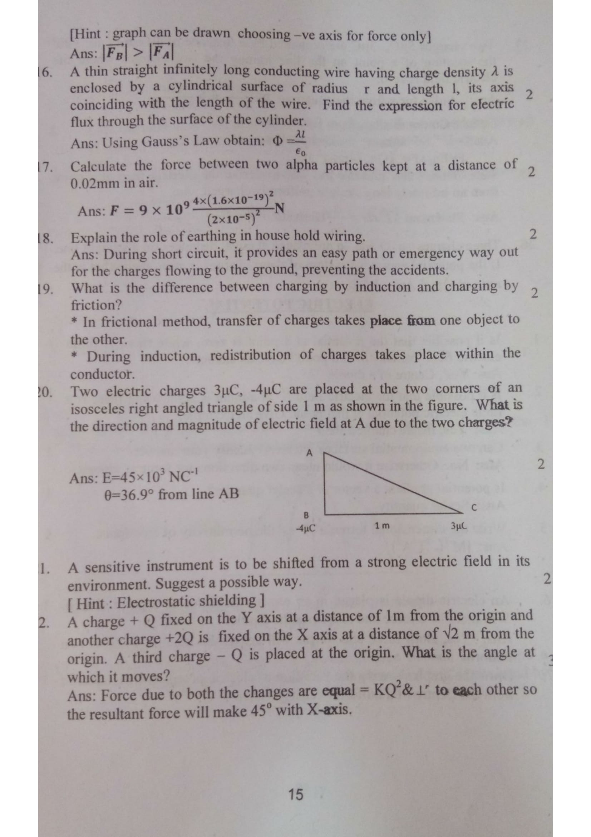
20. Two electric charges 3µC, -4µC are placed at the two corners of an isosceles right-angled triangle of side 1m as shown in the figure. What is the direction and magnitude of electric field at A due to the two charges?

21. A sensitive instrument is to be shifted from a strong electric field in its environment. Suggest a possible way,
22. A charge + Q fixed on the Y axis at a distance of 1m from the origin and another charge +2Q is fixed on the X axis at a distance of √2m from the origin. A third charge -Q is placed at the origin. What is the angle at which it moves?
23. Two charges 5µC, -3µC are separated by a distance of 40cm in air. Find the location of a point on the joining of a point on the line joining the two charges where the electric field is zero.
24. Deduce Coulomb’s law from Gauss’ law.
25. State Gauss’s law and use this law to derive the electric filed at a point from an infinitely long straight uniformly charged wire.
26. Three charges -q, Q and -q are placed at equal distances on a straight line. If the potential energy of system of these charges is zero, then what is the ratio of Q: q.

Electric Potential
1 Marks
1. Is it possible that the potential at a point is zero, while there is finite electric field intensity at that point? Give an example.
2. Is it possible that the electric field at a point is zero, while there is a finite electric potential at that point. Give an example.
3. Can two equipotential surfaces intersect? Justify your answer.
4. Is potential gradient a vector or a scalar quantity?
5. Write the dimensional formula of ‘C_{o}’ the permittivity of free space.
6. An electric dipole is placed in an electric field due to a point charge. Will there be a force and torque on the dipole?
7. Draw the graph showing the variation of electric potential with distance from the centre of a uniformly charged shell.
8.Find the ratio of the electric field lines starting from a proton kept first in vacuum and then in a medium of dielectric constant 6.
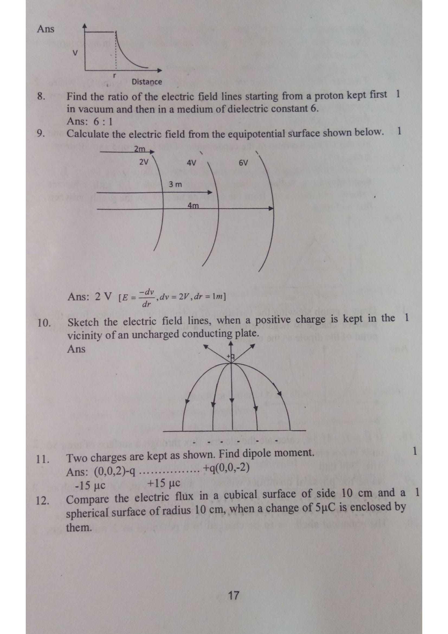
9. Calculate the electric field from the equipotential surface shown below.

10. Sketch the electric field lines when a positive charge is kept in the 1 vicinity of an uncharged conducting plate.
11. Two charges are kept as shown. Find dipole moment.
12. Compare the electric flux in a cubical surface of side 10cm and a spherical surface of radius 10cm, when a change of 5µC is enclosed by them.
13. Explain why the electric field inside a conductor placed in an external electric field is always zero.

2 Marks

14. Two identical metal plates are given positive charges Q₁ and Q₁ where Q₁ > Q_{2.} Find the potential difference between them, if they are now brought together to form a parallel plate capacitor with capacitance.
15. 27 small drops of mercury having the same radius collage to form one big drop. Find the ratio of the capacitance of the big drop to small drop.
16. A uniformly Charged rod with linear charge density λ of length L is inserted into a hollow cubical structure of side ‘L’ with constant velocity and moves out from the opposite face. Draw the graph between flux and time.
17. Draw a graph showing the variation of potential with distance from the positive charge to negative charge of a dipole, by choosing the mid-point of a dipole, by choosing the midpoint of the dipole as the origin.
18.If = 3i+4j-5K, calculate the electric flux through a surface of area 50 units in z-x plane.
19. Name the physical quantities whose SI units are Vm, Vm⁻¹. Which of these are vectors?
20. The spherical shell is to be charged to a potential of 2 million colt. Calculate the minimum radius the sell can have, if the dielectric strength of air is 0.8 KV/mm.
21. How will you connect seven capacitors of2µf each to obtain an effective 2 capacitance of 10/11 µf.
22.A proton moves with a speed of 7.45 * 10⁵ m/s directly towards a free proton initially at rest. Find the distance of the closest approach for the two protons.
23.Three-point charges of 1C, 2C, & 3C are placed at the corners of an equilateral triangle of side 1m. Calculate the work done to move these charges to the corners of a smaller equilateral triangle of sides 0.5m.
24. Suggest an arrangement of three-point charges, +q, +q, -q separated by finite distance that has zero electric potential energy.
25. A point charge Q is placed at point O as shown. Is the potential difference (V_{A}-V_{B}) positive, negative or zero if Q is (i) positive (ii) negative.

3 Marks
26. Show that the potential of a changed spherical conductor, kept at the Centre of a charged hollow spherical conductor is always greater than that of the hollow spherical conductor, irrespective of the charge accumulated on it.
27. Calculate the capacitance of a system having five equally spaced plates, if the area of each plate is 0.02 m² and the separation between the neighbouring are 3mm In case (a) and (b)
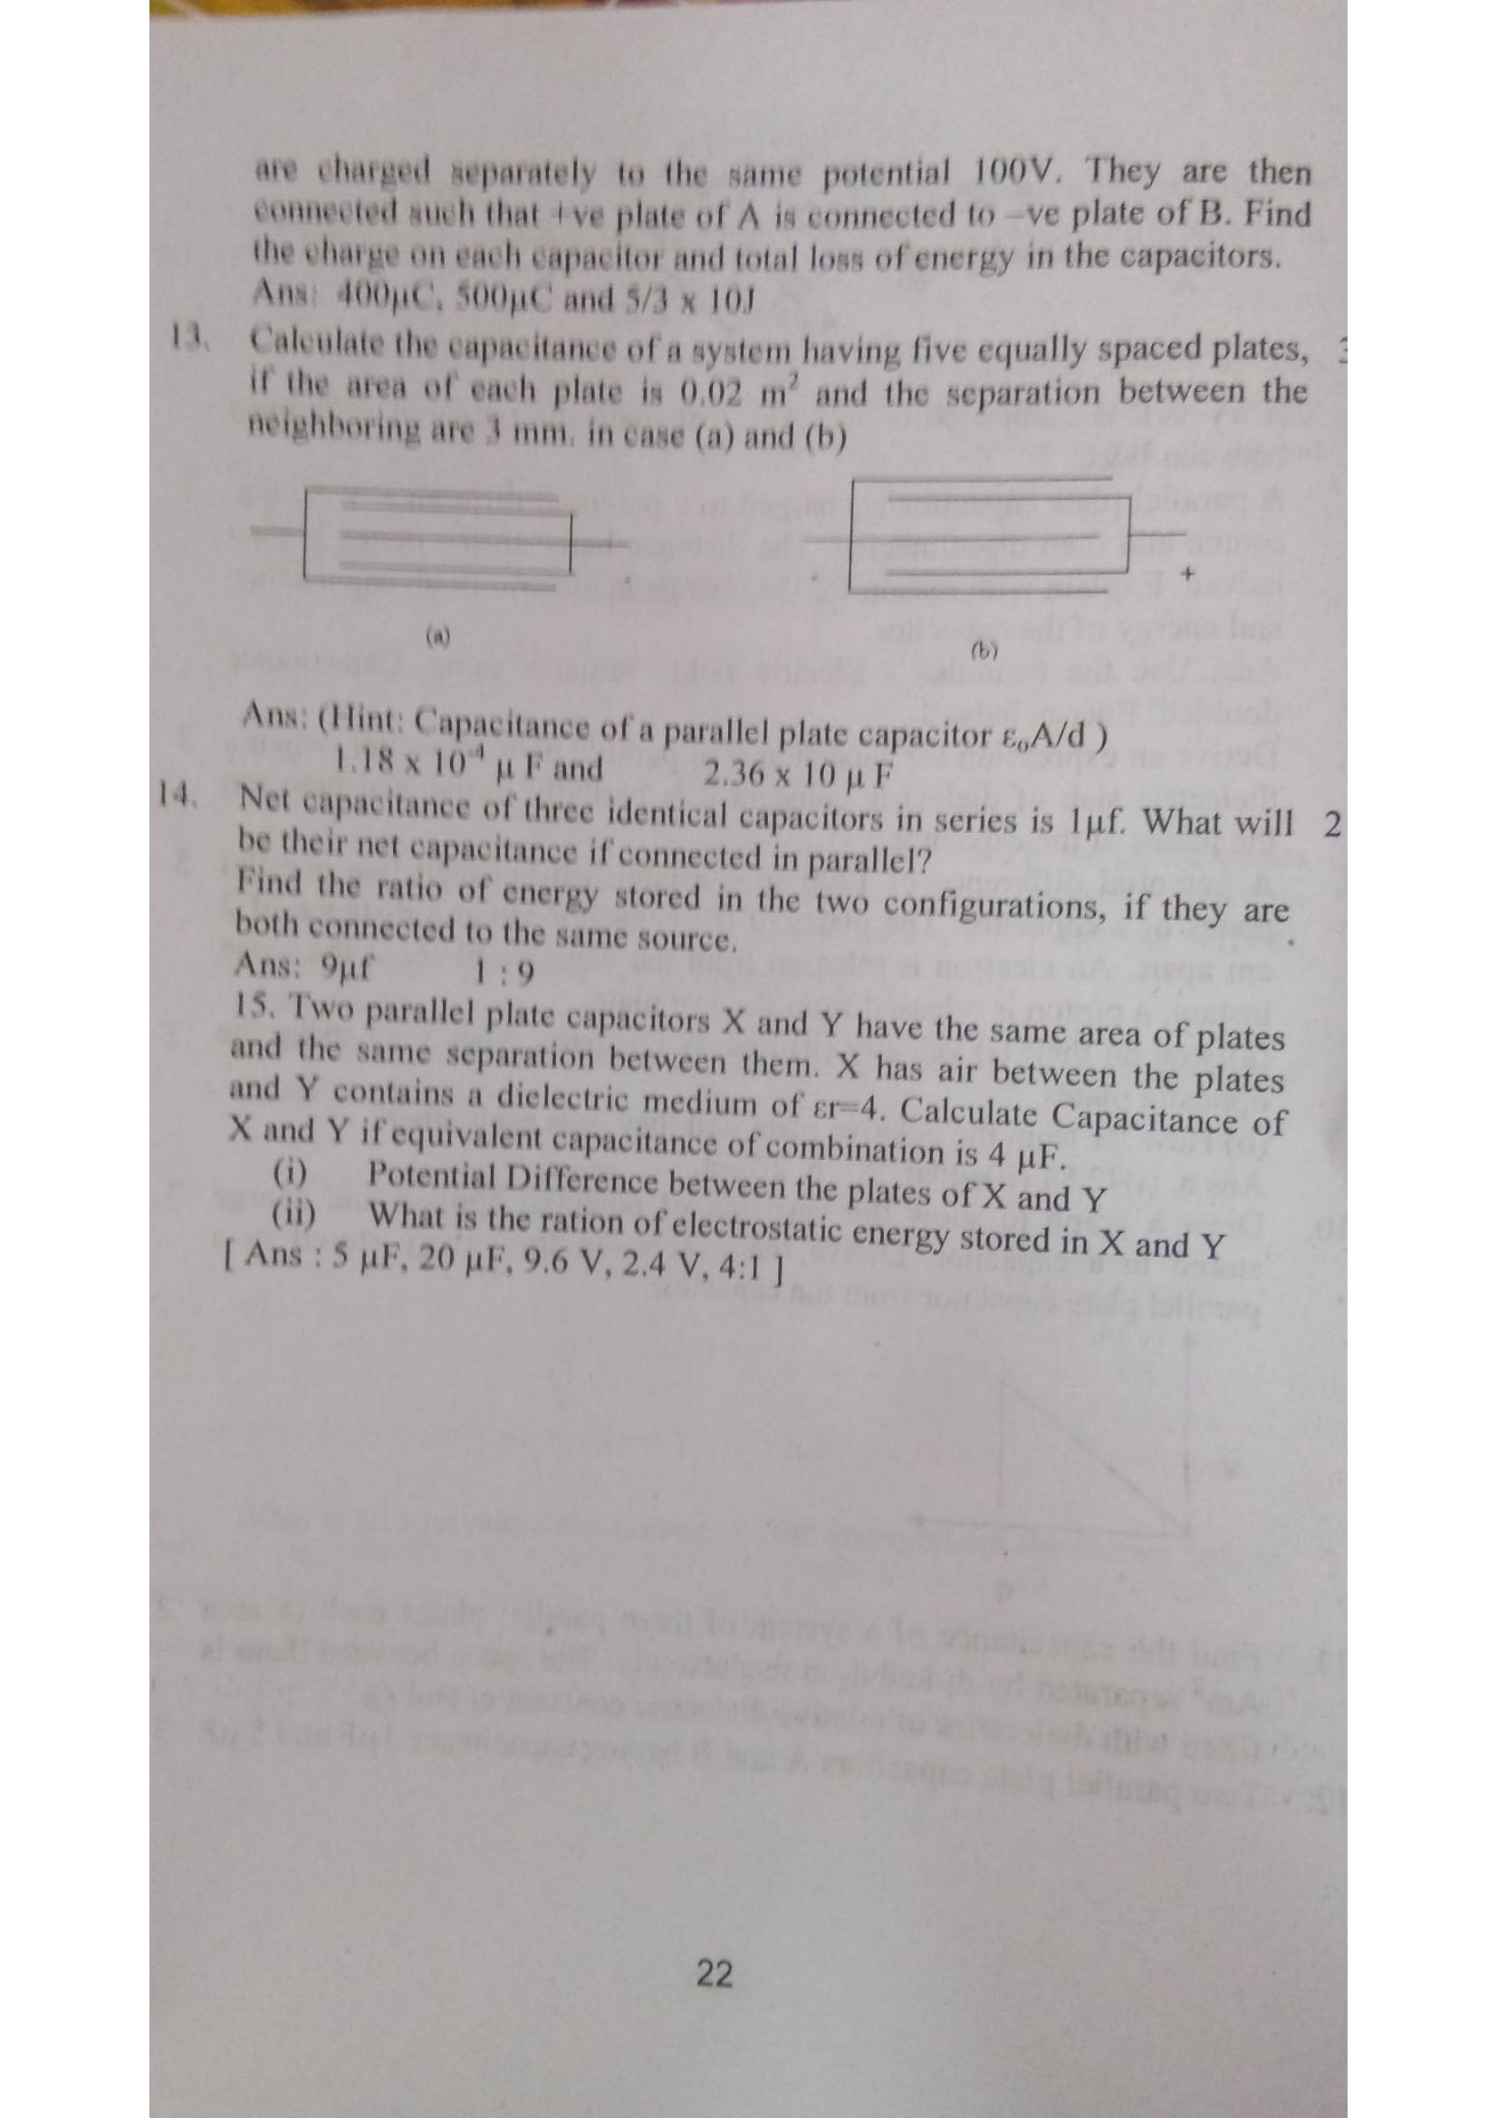

(a) (b)
28. Net capacitance of three identical capacitors in series is 1µf. What will be their net capacitance id connected in parallel? Find the ratio of energy stored in the two configurations, if they are both connected to the same source.
29. Two Parallel plate capacitors X and Y have the same area of plates and the same separation between them. X has air between the plates and Y contains a dielectric medium of cr=4. Calculate Capacitance of X and Y if equivalent capacitance of combination is 4µF.
(i) Potential Difference between the plates of X and Y
(ii) What is the ration of electrostatic energy stored in X and Y.

